|  |
| --- |
| 新东方在线英语学习 |
| 新概念 1 册 |
| Lesson49-50 |



扫一扫。更多有趣的英语资讯。

# Lesson 49 单词讲解

1. butcher: 卖肉的bu che er

at the butcher’s: 在肉店bu che er s

at the doctor’s: 在诊所

at the hairdresser’s: 在理发店

at the baker’s: 在面包店……

1. meat: 肉,不可数名词
2. beef: 牛肉
3. lamb : 羔羊肉

mutton: 羊肉ma ten

1. steak: 牛排si dei ke

a piece of steak

1. mince: 肉馅men zi
2. chicken: 鸡肉
3. pork: 猪肉pao er ke

a pound of …

1. husband : 丈夫ha si ben d
2. tell: 告诉

tell sb. sth. 告诉某人某件事

1. truth: 实情、事实

true: adj. 真实的

1. either: 也，ai de er

too: 也，陈述句，疑问句

我也不知道。I don’t know either.either 用于否定句

你也喜欢英语吗？ Do you love English, too?

# Lesson 49 课文讲解

1. Do you want any meat…? Are you…? Do you…? Are you+ 非动词?

Do you + 动词?

Are you…? Do you…?

busy?

a teacher?

at home?

sleep well?

make the bed?

have breakfast? Are you…? Do you…?

Is she\he\it…？ Does she\ he\ it…?

tall?

a boss?

in Beijing?

swim well?

wash your hands?

walk to school?

先看词性: 再看人称:

Are you…? Do you…?

Is she\he\it…？ Does she\ he\ it…?

她是你的女朋友吗？ Is she your girlfriend? 你经常睡得很晚吗？ Do you go to bed late? 他在北京学习吗？

Does he study in Beijing?

先看词性: 动词 or 非动词再看人称: 三单 or 非三单三单: 第三人称单数

she\ he\ it Lucy,

1. Yes, please. No, thank you.
2. But my husband doesn’t.

isn’t, aren’t, don’t & doesn’t?

isn’t+ 非动词, aren’t+ 非动词, don’t+ 动词, doesn’t+ 动词先看词性: 动词 or 非动词 ，再看人称: 三单 or 非三单

练习：他个子不高。

He tall.

他不经常游泳。

He usually swim.

我们不经常见面。

We usually meet.

他们不是坏学生。

They bad students.

她不喜欢肉。

She like meat.

1. To tell you the truth,…

说句老实话吧…

# Lesson 49 语法讲解

一般现在时态：

1. 何时用？
   1. 经常的状态；
   2. 习惯的动作；
   3. 真理。
2. 结构？
   1. 经常的状态； 主语+ is \am\ are
   2. 习惯的动作； 主语+ v. （动词）
   3. 真理。主语+ is \am\ are, 主语+ v.（动词） They are very bad.

They often cheat in the exams. The earth is round.

The sun rises in the east.rai z si

1. 动词 ?

主语+ v.（动词）

主语为非三单 + 动词原形主语为三单 + 动词 s\es

He loves his girlfriend very much.

Jim and Lily walk to school every day. They drink beer every night.

My dog watches TV at night. She goes to school on foot.

# 1). She up(起床) at six in the morning.



**A. get**

**B. gets**

**C. getting**

1. **Tom is a worker. He in a factory.**

**His sisters in a hospital.**

**A. work/ work B. works/ works**

**C. works/work D. work/works**

1. 疑问？

They drink beer every night.

Do they drink beer every night? He loves his girlfriend very much.

Does he love his girlfriend very much?

先看词性，再看人称

1. 否定？

They drink beer every night.

They don’t drink beer every night. He loves his girlfriend very much.

He doesn’t love his girlfriend very much?

先看词性，再看人称

# - How you go to school?

**- I go to school by bus. But my brother**

**school on foot.**

**A. do, go to B. are, go to**

**C. do, goes to D. are, goes to**

1. **Lucy want to go shopping with her. But she must.**

**A. don’t B. aren’t**

**C. isn’t D. doesn’t**

**Lesson 50 单词句型讲解**

1. tomato: 西红柿te ma tou
2. potato: 土豆pu dei dou
3. cabbage: 卷心菜kai beizhi
4. lettuce: 莴lai de si
5. pea: 豌豆

# bean: 豆角ben en

1. **pear: 梨pei er**
2. **grape: 葡萄**
3. **peach: 桃子pi chi**

am not, aren’t, isn’t, can’t, don’t, doesn’t

先看词性，再看人称

1. He likes coffee, but I .
2. 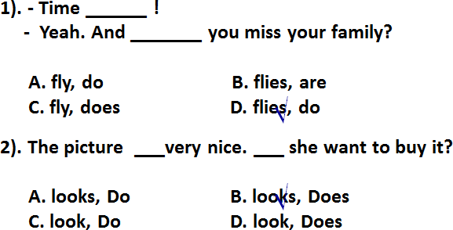She likes tea, but he .



1. He is eating some bread, but she .
2. She can type very well, but he .
3. They are working hard, but we .
4. He is reading a magazine, but I .

**Lesson 49&50 知识拓展**

# 主语为三单，动词要变化; 主语为三单，提问用 does;

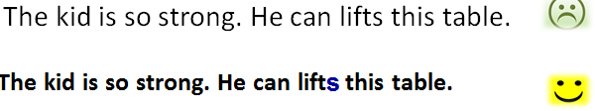**主语为三单，否定用 doesn’t.**